Preview of entity before normalization.

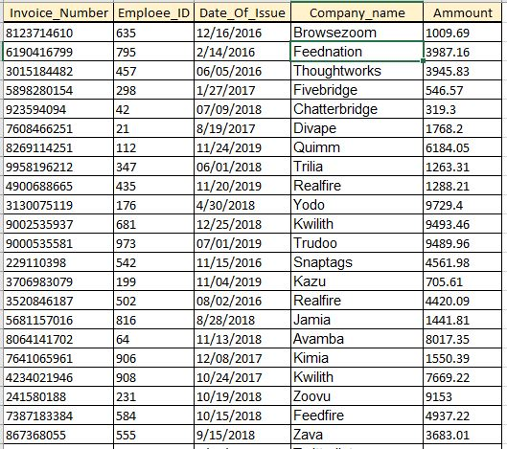

1NF & 2NF

PK is invoice_number.

FK is employee_ID.

All attributes depend on PK.

All values are atomic and from same type, and all attributes have reasonable and understandable names.

3NF

Entity is in 2NF, there is none transitive dependency.

Preview of table after normalization:

